## **Problem Statement**

The Michigan Flower Growers’ Cooperative (MFGC) has a system that allows for florists to pre-order flowers from growers at their weekly market. However, their current system, which runs off of Google Sheets, proves itself to be inconvenient for the florists, retailers, and event planners who are placing preorders, the growers who need to input what flowers they will have available, and the MFGC staff who have to consolidate this information. Therefore, MFGC is in need of a way to more efficiently and effectively collect pre-order information.

## **Michigan Flower Growers’ Cooperative**

Founded in 2016, the Michigan Flower Growers’ Cooperative (MFGC) is the only Michigan flower cooperative, consisting of 18 experienced growers from Michigan and northern Ohio.1,2 It is member-owned and all products sold through the cooperative are grown on the members’ farms.3 The goal of MFGC is “to provide the highest-quality, most diverse offering of Michigan-grown cut flowers and foliages for the floral trade with the convenience of a once-weekly, aggregated marketplace.”4 Additionally, the cooperative places an emphasis on the benefits it can provide to the growers, such as saving time on marketing and delivery.5

One of the key functions of the organization is its weekly wholesale market that runs from spring to fall.6 At the market, the businesses that have bought into the co-op sell their flowers to customers. Certain customers, including studio florists, retailers, and event planners, are also able to purchase a buyer pass that allows them to shop and also place pre-orders.7 Individuals are also able to buy cut flowers at the market, though MFGC does focus much of its attention on wholesale orders.8 Having this marketplace is yet another benefit that MFGC provides growers since it allows them to serve multiple customers in one location while also facilitating a relationship between growers and buyers.9

## **Users & Current Platform**

The users of this platform are the eighteen growers who are inputting the flowers they have available to pre-order as well as the numerous florists, retailers, and event planners who are pre-ordering the flowers.

Currently, the system runs off of Google Sheets. First, growers input the flowers they will have available for preorder for the following week’s market. Each grower has their own separate sheet that they populate manually with the flowers they will have available for the next market.

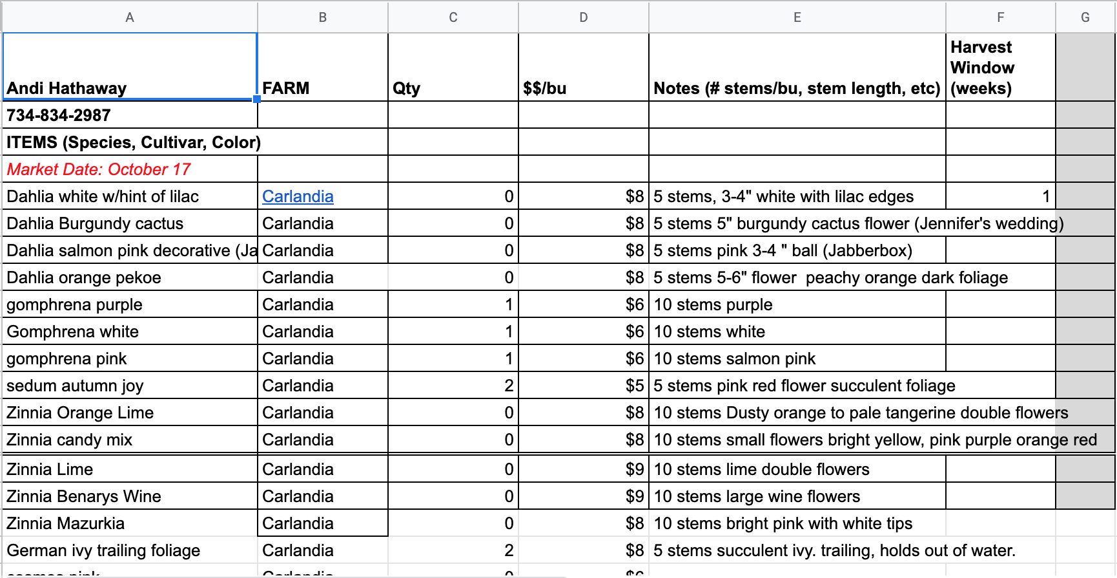

*Figure 1. Each farmer has their own individual spreadsheet that they manually populate with their flower quantities for the week.*

Once all growers have put in their information, the market manager of MFGC organizes this information into another sheet, which they then push to buyers. The buyers then place their orders on the sheet - each has their own column, and the rows are the flowers available from the growers.

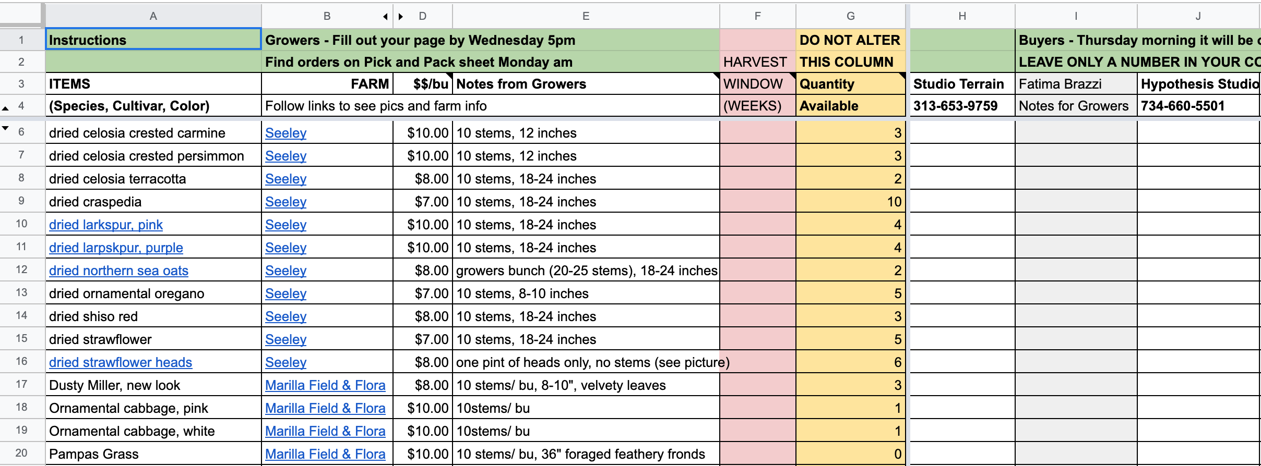

*Figure 2. There is a sheet with aggregated information on what flowers will be available from which farms for the buyers. Columns A through G have the information on what flowers are available. Columns H through J is where the buyers would place their pre-orders (more buyers are shown when scrolling sideways). Column G, quantity, changes as buyers place their pre-orders.*